Project Performance Test

Date | 09 July 2026
Team ID
Project Name | Food Ordering Behaviour and Consumer Trends
Maximum Marks

Model Performance Testing:
S.No. | Parameter | Screenshot / Values
 | Data Rendered | The food ordering dataset was successfully imported into Tableau. It contains customer details, restaurant information, order details, ratings, payment methods, and delivery-related attributes used for analysis.  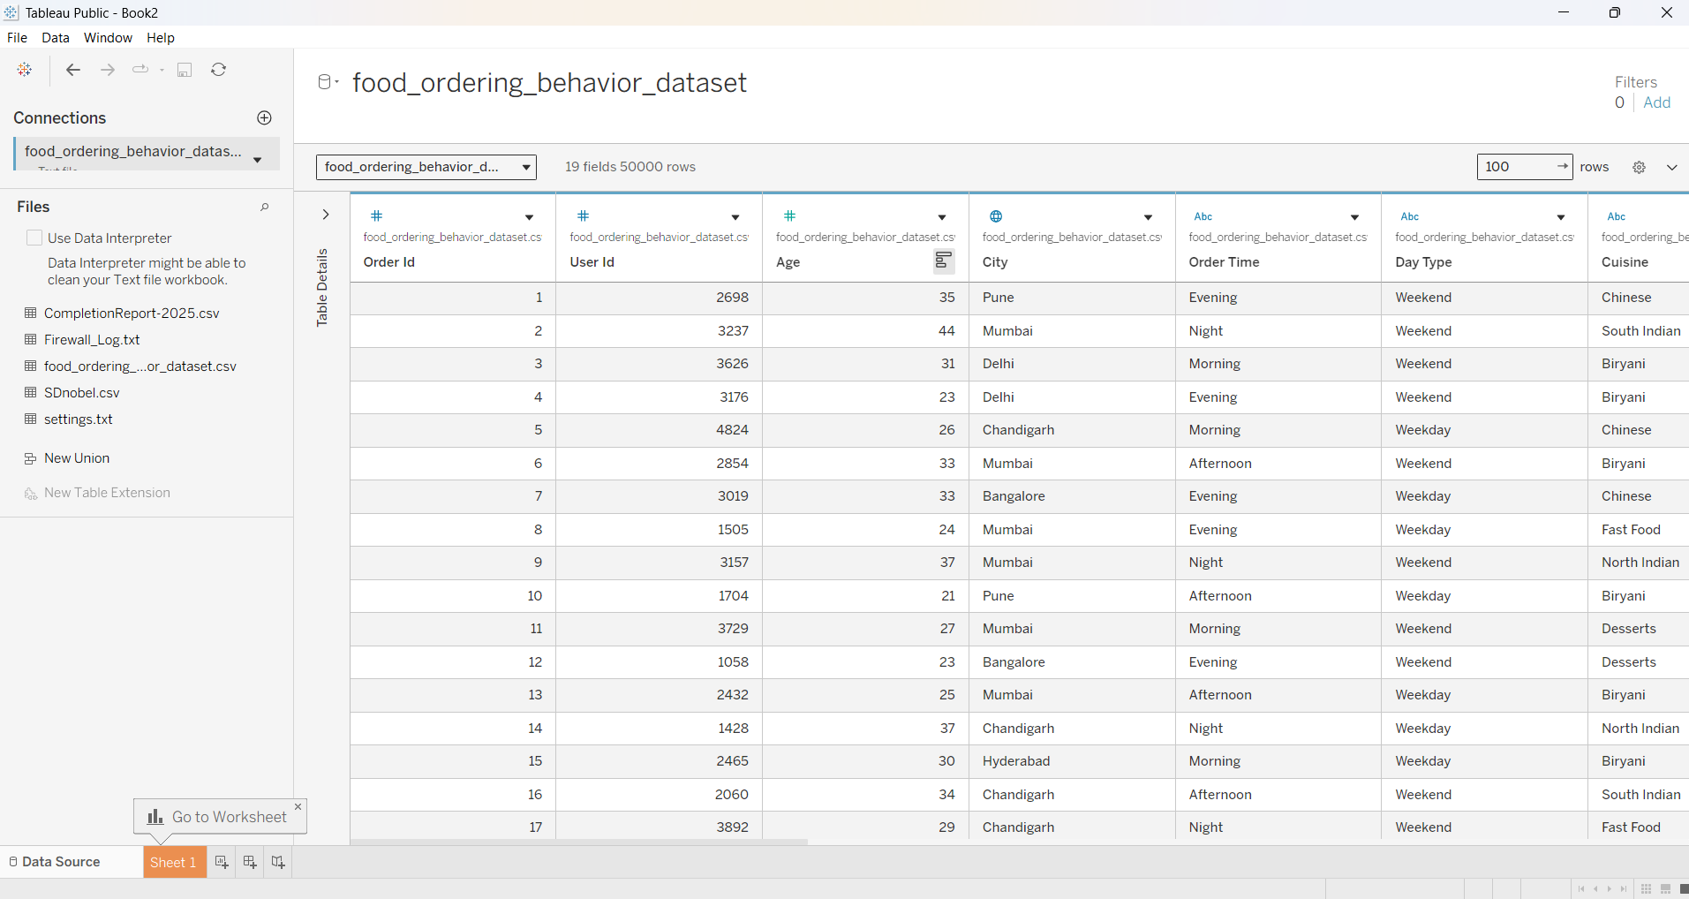
 | Data Preprocessing | Data preprocessing involved handling missing values, correcting data types, removing duplicate records, renaming columns, and preparing the dataset for accurate visualization and analysis.
3. | Utilization of Filters | Interactive filters such as City, Cuisine, Restaurant Name, Order Date, Rating, and Payment Method were implemented to allow users to explore data dynamically and generate customized insights.  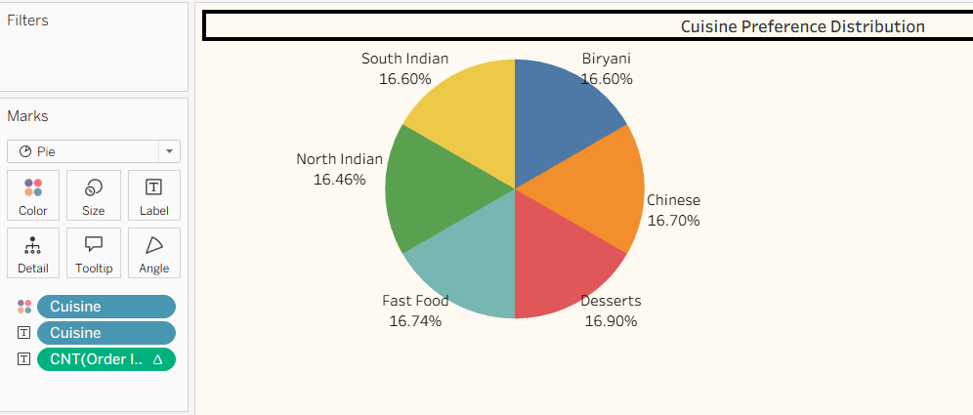
4. | Calculation fields Used | Calculated fields including Total Orders, Average Rating, Total Revenue, Average Order Value, and Order Count were created to measure key business performance indicators and customer trends.  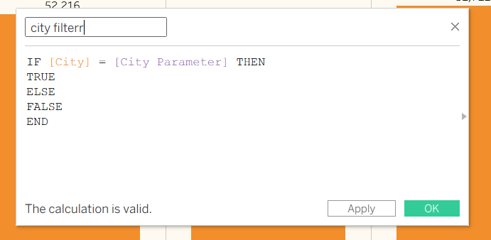
5. | Dashboard design | The dashboard was designed using interactive charts, KPIs, bar graphs, line charts, pie charts, and filters to provide a comprehensive view of customer behaviour, restaurant performance, and food ordering trends.  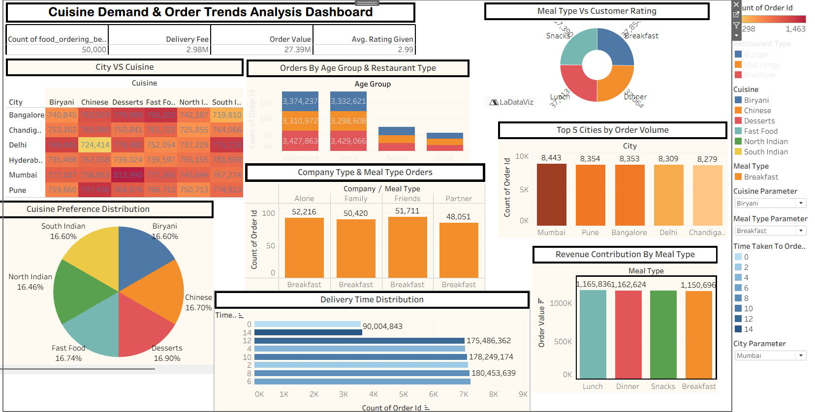
6 | Story Design | Tableau Story was created to present the analysis in a logical sequence, highlighting customer preferences, popular cuisines, peak ordering hours, restaurant performance, and actionable business insights.  